TCP wireshark lab

**Lab 1 :**

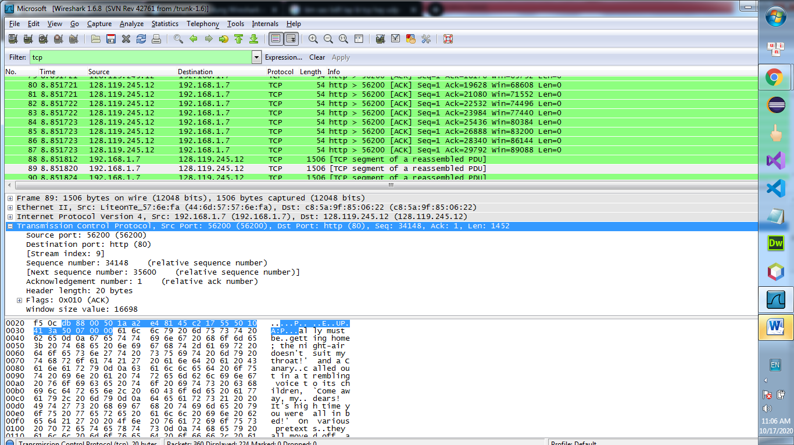

**Lab 2 :**

1. The IP address and TCP port number used by the client computer is :

* IP Address : 192.168.1.7
* TCP Port number : 56200

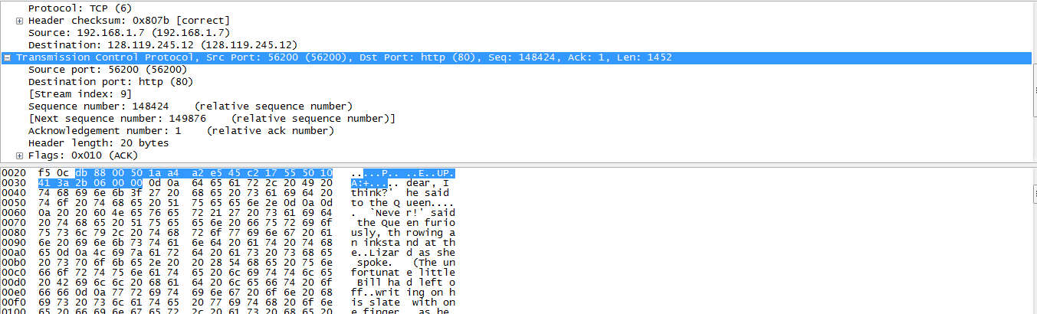

1. - IP Address : 128.119.245.12

* TCP Port number : 80

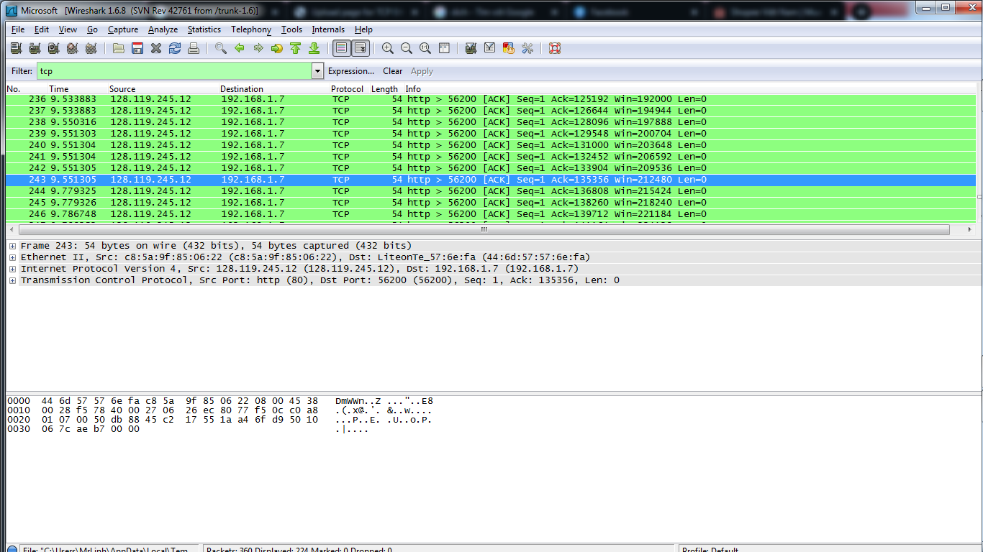

This my screen after uncheck HTTP follow guide.

Lab 3 :

* that sequence number is 0 in this trace.
* The SYN flag is set to 1 we know this segment is a SYN segment.

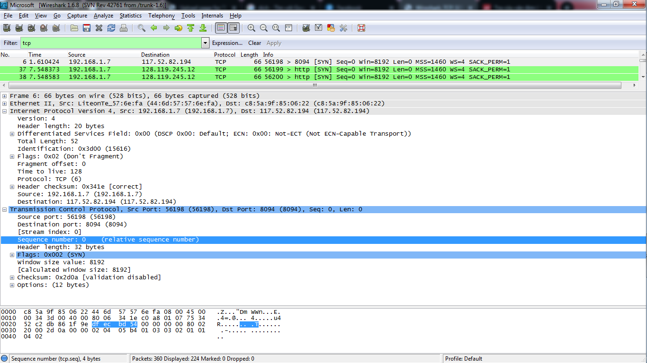

* The sequence number of the SYNACK in this trace is : 0
* The value of the Acknowledgement field in the SYNACK segment in this trace is 1. It is determined by gaia.cs.umass.edu by adding 1 to the initial sequence number of SYN segment.
* The SYN flag and Acknowledgement flag in the segment are set to 1 from that we know this segment is SYNACK segment.

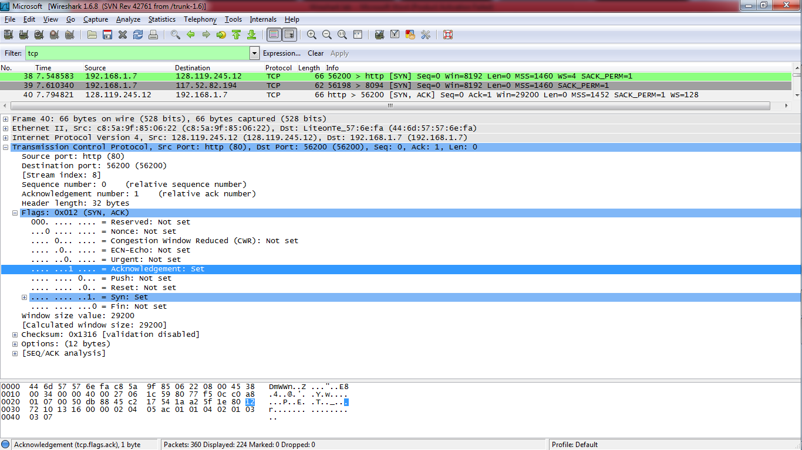

* 42th Segment is the TCP segment containing the HTTP POST command, but this segment value is 1 and it in below picture :

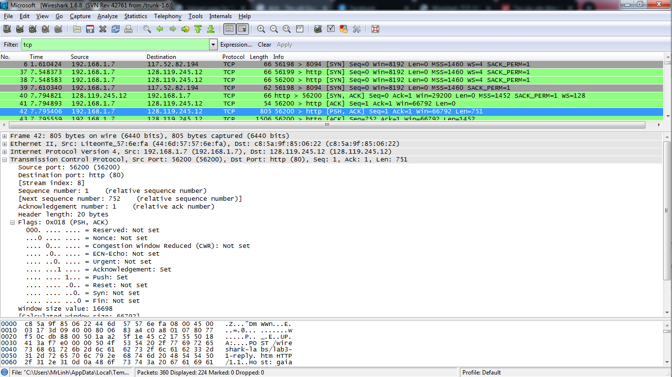

8.

- The minimum amount of buffer space is : 1250 show in the first acknowledgement from the server. This receiver window grows steadily until a maximum receiver buffer. The sender is never throttled due to lacking of receiver buffer space by inspecting this trace.

10.

- There are no retransmitted segments in the trace file. We can verify this by checking the sequence numbers of the TCP segments in the trace file. In the TimeSequence-Graph (Stevens) of this trace, all sequence numbers from the source (192.168.1.7) to the destination (128.119.245.12) are increasing monotonically with respect to time. If there is a retransmitted segment, the sequence number of this retransmitted segment should be smaller than those of its neighboring segments.

11.

- The computation of TCP throughput largely depends on the selection of averaging time period. As a common throughput computation, in this question, we select the average time period as the whole connection time. Then, the average throughput for this TCP connection is computed as the ratio between the total amount data and the total transmission time. The total amount data transmitted can be computed by the difference between the sequence number of the first TCP segment.